|  |  |  |
| --- | --- | --- |
| Task 1 |  |  |
| Load Resistance (Ohm) | Load Voltage (V) | Power Dissipated (W) |
| 4000 | 1.95E-01 | 0.000004753125 |
| 6100 | 2.59E-01 | 0.000005498442623 |
| 8100 | 3.00E-01 | 0.000005555555556 |
| 10000 | 3.35E-01 | 0.00000561125 |
| 15100 | 3.86E-01 | 0.000004933642384 |
| 20000 | 4.12E-01 | 0.0000042436 |

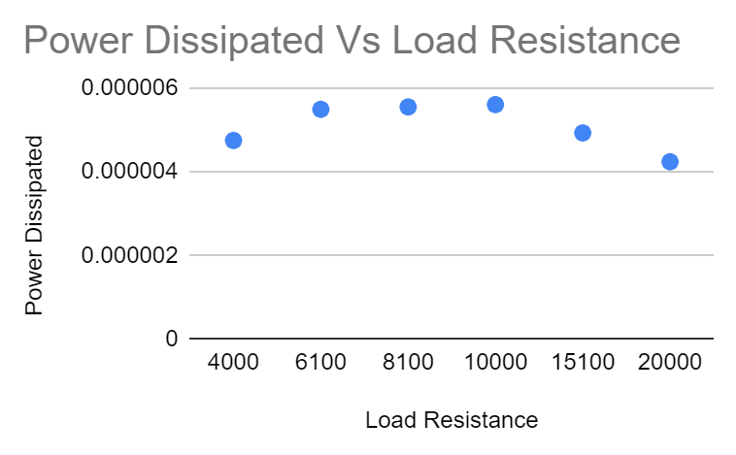

|  |  |  |  |
| --- | --- | --- | --- |
| Task 2 |  |  |  |
| Load Resistance (Ohm) | Shunt Capacitor (F) | Load Voltage (V) | Power Dissipated (W) |
| 10000 | 5.00E-10 | 3.65E-01 | 0.00000666125 |
| 10000 | 7.60E-10 | 3.93E-01 | 0.00000772245 |
| 10000 | 1.00E-09 | 4.01E-01 | 0.00000804005 |
| 10000 | 1.65E-09 | 4.25E-01 | 0.00000903125 |
| 10000 | 1.98E-09 | 3.94E-01 | 0.0000077618 |
| 10000 | 3.33E-09 | 3.63E-01 | 0.00000658845 |
| 10000 | 4.00E-09 | 2.61E-01 | 0.00000340605 |

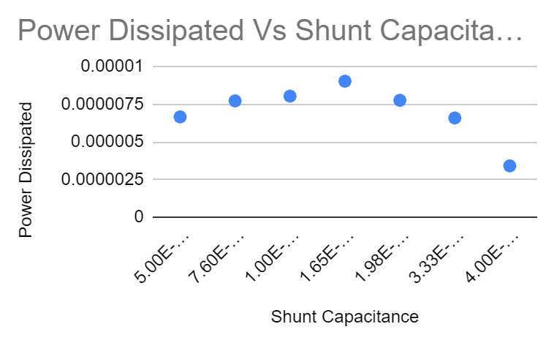

|  |  |  |  |
| --- | --- | --- | --- |
| Task 3 |  |  |  |
| Load Resistance (Ohm) | Shunt Capacitor (F) | Load Voltage (V) | Power Dissipated (W) |
| 10000 | 1.65E-09 | 4.25E-01 | 0.00000903125 |
| 28400 | 1.98E-09 | 6.70E-01 | 0.000007903169014 |